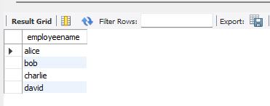

## **Supplier Database**

### **Question (Week 7)**

1. Using Scheme diagram, Create tables by properly specifying the primary keys and the foreign keys.
2. Insert appropriate records in each table.
3. Find the pnames of parts for which there is some supplier.
4. Find the snames of suppliers who supply every part.
5. Find the snames of suppliers who supply every red part.
6. Find the pnames of parts supplied by Acme Widget Suppliers and by no one else.
7. Find the sids of suppliers who charge more for some part than the average cost of that part (averaged over all the suppliers who supply that part).
8. For each part, find the sname of the supplier who charges the most for that part.

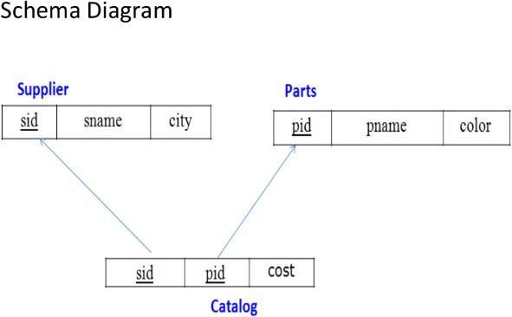

### **Create Database**

Create database supplier_410; Use supplier_410;

## **Create tables**

**create table** supplier( sid int **primary key,** sname varchar(20), city varchar(30)

);

desc supplier;

**create table** parts( pid int **primary key,** pname varchar(20), color varchar(20)

);

desc parts;

**create table** catalog(

sid int, pid int, cost int,

**foreign key**(sid) **references** supplier(sid),

**foreign key**(pid) **references** parts(pid)

);

desc catalog;

**Supplier Table**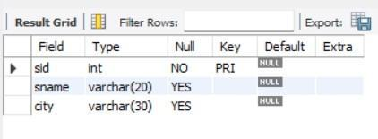

**Parts Table**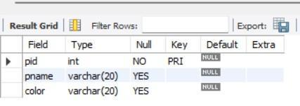

**Catalog table**

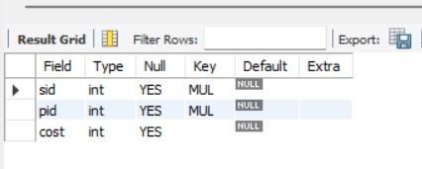

## **Inserting the values**

insert into supplier values (10001, "acne", "Bangalore"),

(10002, "johns", "Kolkata"),

(10003, "vimal", "Mumbai"),

(10004, "reliance", "Delhi"); select * from supplier;

###### **Supplier Table**

(20001,"Book","Red"),

(20002,"Pen","Red"),

(20003,"Pencil","Green"),

(20004,"Mobile","Green"),

(20005,"Charger","Black"); select * from parts;

###### **Parts Table**

(10001,20001,10),

(10001,20002,10),

(10001,20003,30),

(10001,20004,10),

(10001,20005,10),

(10002,20001,10),

(10002,20002,20),

(10003,20003,30),

(10004,20003,40);

select * from catalog;

**Catalog Table**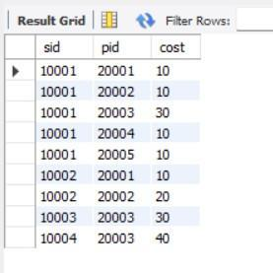

### **Queries**

* **Find the pnames of parts for which there is some supplier. select** pname **from** parts **where** pid **in** (**select** pid **from** catalog);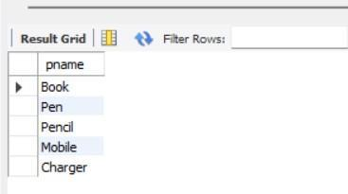

###### **Find the snames of suppliers who supply every part. select** sname **from** supplier **where sid in**

(**select sid from** catalog **group by sid having count**(**distinct** pid) = (**select count**(**distinct**

pid) **from** parts));

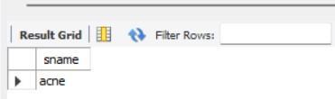

42

###### **Find the snames of suppliers who supply every red part.**

**select distinct** sname **from** supplier, parts, catalog

**where** supplier.sid = catalog.sid **and** parts.pid = catalog.pid **and** parts.color="Red";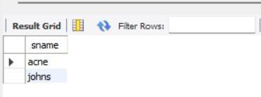

###### **Find the pnames of parts supplied by Acme Widget Suppliers and by no one else. select** pname **from** parts **where** pid **not in**

(**select** pid **from** catalog **where sid in** (**select sid from** supplier **where** sname != "acne"));

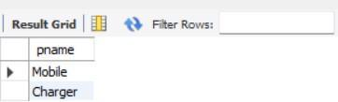

###### **Find the sids of suppliers who charge more for some part than the average cost of that part (averaged over all the suppliers who supply that part).**

**select sid from** catalog a **where** a.cost > (**select avg**(b.cost) **from** catalog b **where** a.pid = b.pid **group by** b.pid);

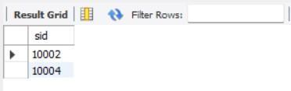

###### **For each part, find the sname of the supplier who charges the most for that part.**

**select** pid, sname **from** catalog a, supplier **where** a.cost = (select max(b.cost) **from**

catalog b **where** a.pid = b.pid group by b.pid) and supplier.sid = a.sid;

